
PROJECT PAPER

Course Code: CSE 477
Course Title: Data Mining
Semester: Spring 2018
Section: 02
Group Members and ID’s: Al-Imran
2013-2-60-048
Mustafa Wasif Allvi
2015-1-60-022
Mohammad Jashem
2015-1-60-027

Submitted to:
Dr. Shamim Hasan Ripon
Associate Professor
Dept. of CSE
East West University

Date of Submission: April 9th, 2018/MONDAY
Burst Header Packet (BHP) flooding attack on Optical Burst Switching (OBS)
using network DataSet

Al-Imran
ID:2013-2-60-048
Department of Computer Science and Engineering
East West University
Mohammad Jashem
ID:2015-1-60-027
Department of Computer Science and Engineering
East West University

Mustafa Wasif Allvi
ID:2015-1-60-022
Department of Computer Science and Engineering
East West University

Abstract—Optical burst switching (OBS) network is a promising switching technology for building the next generation of internet backbone infrastructure. It works by assembling UDP packets and sending a burst header packet (BHP) in order to preserve the required network resources along the path before sending the corresponding data burst. If a source node (ingress) gets compromised by an attacker and floods the network with only BHPs to reserve resources without sending actual data, a denial of service attack can occur. In this paper, we propose and develop a new security model that can be embedded into an OBS core switch architecture to prevent BHP flooding attacks. The countermeasure security model allows the OBS core switch to classify the ingress nodes based on their behavior and the amount of reserved resources that are not being utilized. A malicious node that causes BHP flooding attack will be blocked by the developed model until the risk disappears. We applied several algorithms to see the BHP OBS and have the counter record as well. The analysis conducted reveals that the number of BHP flooding’s success or failure rate to counter OBS.
Keywords—Optical Burst Switching Network(OBS), UDP protocol, Burst Header Packet(BHP), flooding attack sliding range window, Naïve Bayes, Decision Table, Decision Tree, Random Tree,Bayes net algorithm.

Introduction
Optical burst Switching (OBS) is an optical networking technique that allows dynamic sub-wavelength switching of data. OBS is viewed as a compromise between the yet unfeasible full optical packet switching (OPS) and the mostly static optical circuit switching (OCS). It differs from these paradigms because OBS control information is sent separately in a reserved optical channel and in advance of the data payload. These control signals can then be processed electronically to allow the timely setup of an optical light path to transport the soon-to-arrive payload. This is known as delayed reservation.
The purpose of optical burst switching (OBS) is to dynamically provision sub-wavelength granularity by optimally combining electronics and optics. OBS considers sets of packets with similar properties called bursts. Therefore, OBS granularity is finer than optical circuit switching (OCS). OBS provides more bandwidth flexibility than wavelength routing but requires faster switching and control technology. OBS can be used for realizing routing but faster switching and control technology. OBS can be used for realizing dynamic end-to-end all optical communications.
In OBS networks, each data burst (DB) is associated with a corresponding Burst Header Packet (BHP) which is sent ahead of the DB on different WDM path information for path configuration. If the scheduling request is rejected at one OBS core node, then there will never be validation of optical path setting-up for the arriving Db. Since, the DB will arrive anyhow to an input port core node which no longer belongs to its corresponding BHP; it will be dropped or reach to unpredictable destination. When the BHP arrives at the compromised core node, the attacker will start launching abuse actions before the corresponding DB reaches the desired node. In such cases, the attacker injects a malicious BHP instead of original BHP and initiates new relationship between the malicious BHP and the reserved DB; in the new BHP, the forwarding path of incoming DB is changed to a fake and no-desired destination. This attack is called Data Burst Redirection.
For such incidence we applied many algorithms to see the outcome a given dataset. In the dataset we will be working on various attributes like the “flood status”, “packet-lost” etc. and there are e classes such as: NB-No-block, Block, No Block, and NB-wait.
There are 1075 number of instances in the dataset. One of the primary challenges in identifying the risk of the Burst Header Packet (BHP) flood attacks in Optical Burst Switching Networks (OBS) is scarcity of reliable historical data.

COmponents using in predictive Modelling

Data Preparation:
Weka: Waikato Environment Knowledge Analysis is a suite of machine learning software written in Java, developed at the University Of Waikato, New Zealand. It is free software licensed under the GNU General Public License.

Performance Matrix:
- Cross Validation Score: In Cross validation each record is used the same number of times for training and exactly once for testing. For example, in a 2-fold cross validation method, choose one of the subsets for training and the other for testing. Then swap the roles of the subsects so that the previous training set becomes the test set and vice versa. For analysis, 10-fold cross validation method has been used. Thereby ruling out the possibility of over fitting the data. Hence, CV scores of accuracy, precision, recall and F1 Score have been considered for elevating the performance of our model.
- Accuracy, Precision, Recall and F1 score: performance of a model is measured by reflection of well observed actual events. While training of a model is measured by reflection of well observed actual events. While training any model, a labelled data set that includes the actual values to be predicted is considered. This introduced the concepts of a confusion matrix. It gives a relation between an actual and predicted class.
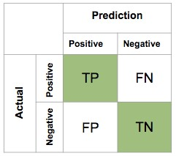
Figure: Confusion matrix.
True positives and true negatives are observations which were correctly predicted, and therefore shown in green. The terms “false positive” and “false negative” can be confusing. False negatives are observations where the actual event was positive. The way to think about it is that the terms refer to the observations and not to the actual events. So, if then the term starts with “false”, the actual value is the opposite of the word that follows it.
Evaluating Measure  Decision Tree Classifier- Clean data | 10-fold Cross-Validation (%)
Accuracy | 99.63%
Precision | 99.8%
Recall | 99.7%
F1 score | 99.7%
Accuracy is simply the ratio of correctly predicted observations and is given by:
Accuracy =

Precision and Recall is given by:
Precision =
Recall =
F1 Score is a harmonic mean of Precision and Recall.

Experimental Results
- DECISION TREE: The decision tree was built to predict the largest column, after splitting the dataset into random training and test sets.
The dataset was used for the burst header attack prediction on to the Optical burst switching and the by using the cross-validation procedure to reduce the overfitting. In the k-fold cross validation, the training set is split into k-subsets and the model is trained using remaining k-1fold cross-validation, the training data. The average of the values computed is then taken into consideration for calculating the confusion matrix. The accuracy, precision and recall values calculated after performing 10-fold cross validation on the decision tree gave the values, which are much more realistic and practical as opposed to those obtained with the over fitted data (100%).

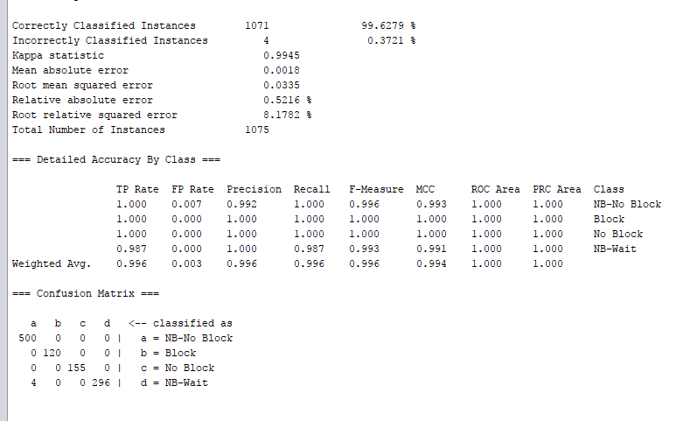

By using the confusion matrix, we get….

Table 1: Performance Measures- Decision Trees Clean Data

Graph:

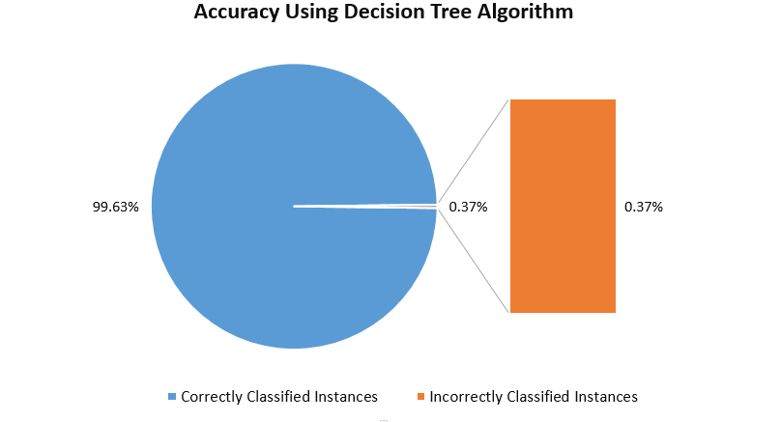

- RANDOM TREE CLASSIFIACTION:
Random Tree Classifiers correct the decision trees habit of overfitting the training dataset. It constructs multiple trees at the training time and outputs a mean prediction in regression and mode prediction in classification of the data set. Gini Index was used as an impurity measures for constructing trees with the help of random tree classifiers. Gini Index gives the separation measure between the probabilistic measures of the target attribute’s values. It is an alternative to Information Gain in Decision trees and Classification.

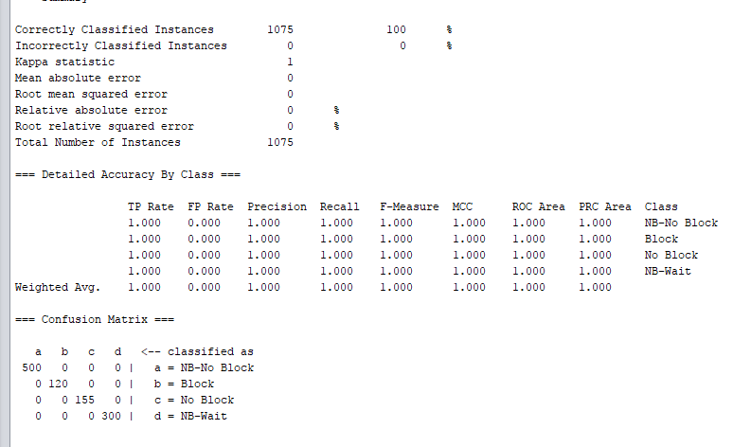
Table 2: Performance Measures- Random Tree Classifier Clean Data
Evaluating Measure  Random Tree Classifier/Clean Data | 10-fold Cross-Validation (%)
Accuracy | 100%
Precision | 100%
Recall | 100%
F1 score | 100%

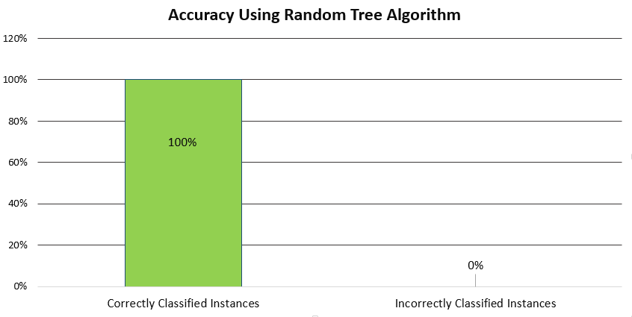
- NAÏVE BAYES CLASSIFICATION: Naïve Bayes classification uses Bayes theorem that describes the probability of an event, based on prior knowledge of conditions that might related to the event. it is given as:

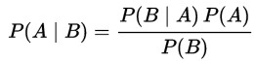
Where P(A|B) = Probability of A given B is true P(B|A) = Probability of B given A is true. P(A)

and
P(B) = Probability of A and B Respectively A: Target and B: Remaining Features

This classifier is implemented in Python using Gaussian Classifier that uses Naïve Bayes Rule for calculating feature importance and their score. Again, to reduce over fitting, cross validation was used to measure accuracy, precision, recall and F1 Score.

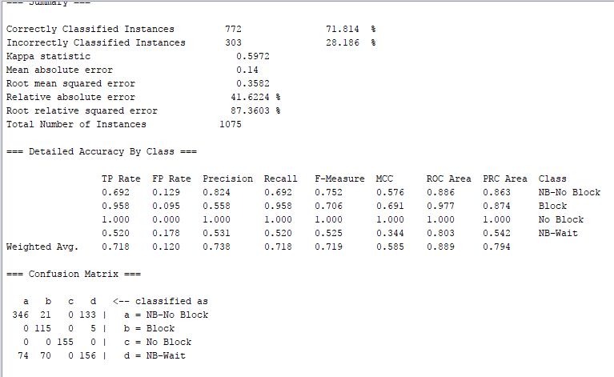

Table 3: Performance Measures- Naïve Bayes Classifier Clean

Evaluating Measure  Naive Bayes Classifier/Clean Data | 10-fold Cross-Validation (%)
Accuracy | 71.84%
Precision | 72.7%
Recall | 79.2%
F1 score | 75.8%

Graph:
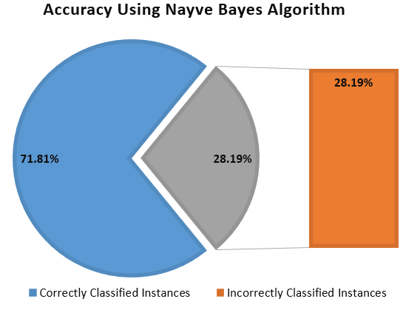
- DECISION TABLE: Decision Table are a concise visual representation for specifying which actions to perform depending on given conditions. They are algorithms whose output is a set of actions. The information expressed in decision tables could also be represented as decision trees or in a programming language as a series of if-then-else and switch-case statements.
Rule-based learning systems also exist. Ross Quinlan’s interactive dichotomize algorithm, known as ID3, selects an arbitrary subset of the training and partitions it according to the variable with the greatest discriminatory power using an information theoretic measure of the latter; basically minimizing entropy. This is repeated until a new rule is found, which is then added to the rule set as in the above example on jobs. Next the entire training set is searched for exceptions to the new rule and if any are found they are inserted in the sample and the process repeated. The difficulties with this approach are that the end result is a sometimes-huge decision tree which is difficult to understand and modify, and that the algorithm does not do very well in the presence of noisy data, though suitable modifications have been developed based on statistical tests.

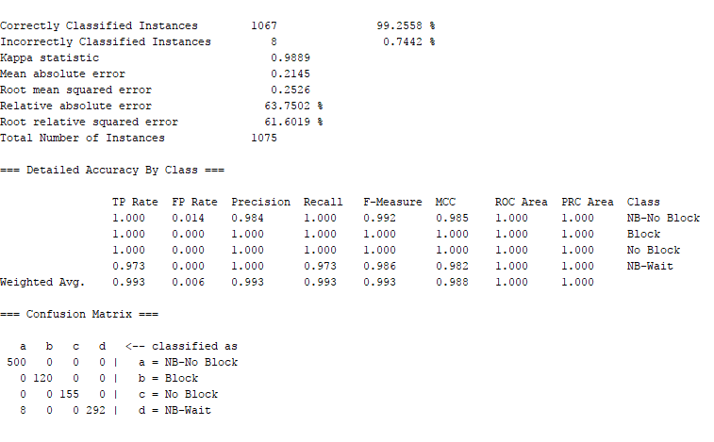
Table 4: Performance Measures- Decision Table Classifier Clean
Evaluating Measure  Decision Table Classifier/Clean Data | 10-fold Cross-Validation (%)
Accuracy | 99.3%
Precision | 99.6%
Recall | 99.3%
F1 score | 99.5%

Graph:
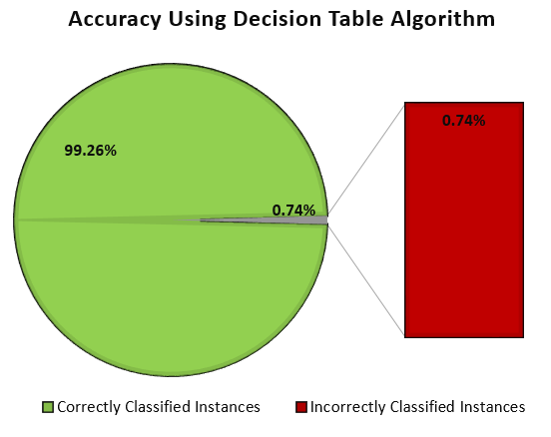

- Bayes Net Rule: A Bayesian network is a graphical model that encodes probabilistic relationships among variables of interest. When used in conjunction with statistical techniques, the graphical model has several advantages for data modeling. One, because the model encodes dependencies among all variables, it readily handles situations where some data entries are missing. Two, a Bayesian network can be used to learn causal relationships, and hence can be used to gain understanding about a problem domain and to predict the consequences of intervention. Three, because the model has both a causal and probabilistic semantics, it is an ideal representation for combining prior knowledge (which often comes in causal form) and data. Four, Bayesian statistical methods in conjunction with Bayesian networks offer an efficient and principled approach for avoiding the overfitting of data. In this paper, we discuss methods for constructing Bayesian networks from prior knowledge and summarize Bayesian statistical methods for using data to improve these models. With regard to the latter task, we describe methods for learning both the parameters and structure of a Bayesian network, including techniques for learning with incomplete data. In addition, we relate Bayesian-network methods for learning to techniques for supervised and unsupervised learning. We illustrate the graphical-modeling approach using a real-world case study.

Table 5: Performance Measures- Bayes Net Classifier Clean

Evaluating Measure  Bayes net Classifier/Clean Data | 10-fold Cross-Validation (%)
Accuracy | 87.81%
Precision | 86.63%
Recall | 89.5%
F1 Score | 88.4%

Graph:
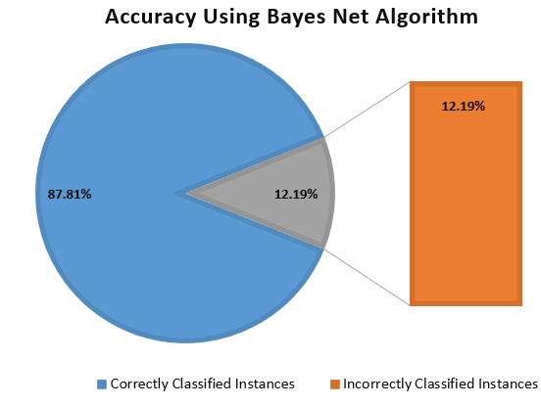

Conclusion
The paper concludes with the decision tree most balanced results with respect to accuracy, precision, recall and F1 score out of five models for prediction the Burst Header Packet flooding in the OBS. And among all the rules and model Random Tree Classifier gives us the more accurate result and correct prediction of the attacker.
The cross-validation folds for all of the above algorithm is 10 and it’s constant for all the algorithms. So, for the better accuracy rather than the Naïve Bayes and the random forest classifier decision tree gives the more accurate result to find out the relation between the Burst Header Block and Not Block relation.

References

- https://archive.ics.uci.edu/ml/datasets/Burst+Header+Packet+%28BHP%29+flooding+attack+on+Optical+Burst+Switching+%28OBS%29+Network#J. Clerk Maxwell, A Treatise on Electricity and Magnetism, 3rd ed., vol. 2. Oxford: Clarendon, 1892, pp.68-73.
- https://www.researchgate.net/publication/309695569_Countering_Burst_Header_Packet_Flooding_Attack_in_Optical_Burst_Switching_Network
- https://link.springer.com/chapter/10.1007/978-3-319-49151-6_22Y. Yorozu, M. Hirano, K. Oka, and Y. Tagawa, “Electron spectroscopy studies on magneto-optical media and plastic substrate interface,” IEEE Transl. J. Magn. Japan, vol. 2, pp. 740-741, August 1987 [Digests 9th Annual Conf. Magnetics Japan, p. 301, 1982].
- https://en.wikipedia.org/wiki/Optical_burst_switching

